**A113 – Mathematics**

**Worksheet for Problem 08: Train Schedule**

**Evolution of public transport in Singapore**

1. Today, the MRT and buses form an integral part of the public transportation system within Singapore, offering Singaporeans a viable alternative to private transport.

How does a reliable and efficient public transport system play a part in nation building?

**Train Profiles**

1. Write down a relationship between velocity, displacement and time.

With this relationship written, if a train was travelling in a straight path at a constant velocity and covered a displacement of 14 km in 15 minutes, what would the velocity of the train be in

1. km/h?
2. m/s?
3. Let us now try to understand more about the train profile of each service provider in “Train Movement” program. The program simulates the velocity reading from the train’s speedometer to produce the corresponding instantaneous velocity-time graph for each service provider. Refer to the file “Train Movement Guide.pptx” to understand how to use the program.

For a start, let’s consider the profile of SMTR. Extract the graph from the program using 30s time interval.

**Different Time Intervals**

1. Figure 1 below shows the velocity-time graph of SMTR (plotted using 30s time interval) that you have extracted in Q3.

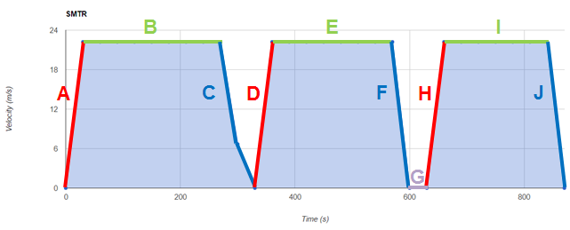

Figure 1

1. Describe the train’s velocity at different intervals.
2. Intervals A, D, H:
3. Intervals B, E, I:
4. Intervals C, F, J:
5. Interval G:
6. Can you identify the exact time where the train first stopped at Bukit Timah in the SMTR profile?
7. Suggest reason(s) for your answer in Q4(b).
8. What can you do differently if you want to determine the exact value in Q4(b)?
9. Based on your response to Q4, what is a more suitable time interval to be used to re-plot the graph in Q3?
10. Extract the graphs for all the different service providers using the time interval specified in Q5.

**Acceleration**

1. According to the comfort regulation, it is recommended that the **acceleration** or **deceleration** of the train should not exceed 1 m/s2.
   1. What do you understand by the term “acceleration”? Write down a relationship between acceleration, velocity and time.
   2. Explain how you can use the graphs from Q6 to determine the acceleration of the train for different service providers.
   3. Analyse whether the train profile of each service provider met the comfort regulation.

**Displacement**

1. Consider the following three scenarios as shown in Table 1.

For scenario A, it is observed that the velocity is maintained at 20.0 m/s over a period of *t* seconds. Observe the shape of the graphs for scenario B and C and describe how their velocity changes over a period of *t* seconds in Table 1.

Table 1

|  |  |  |
| --- | --- | --- |
| Scenario | Velocity-time graph | Comments |
| A |  | Velocity is maintained at 20.0 m/s over a period of *t* seconds. |
| B |  |  |
| C |  |  |

1. Over a period of *t* seconds, which of the above three scenarios has the largest displacement? Which scenario has the least?
2. Explain the method you have used to determine the displacement in each scenario.

**Instantaneous Velocity and Average Velocity**

1. Figure 2 below shows a part of the velocity-time graph for SMRT from *t* = 0 s to *t* = 306 s (using time interval of 1s).

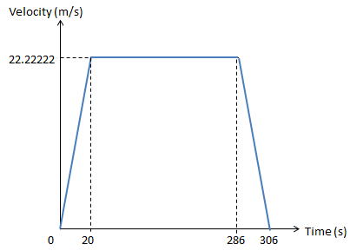

Figure 2

1. Based on the graph, determine the displacement of the train from *t* = 0 s to *t* = 306 s.
2. Hence, compute the average velocity of the train from *t* = 0 s to *t* = 306 s.
3. Using the graph in Figure 2, compute the instantaneous velocity at the following time instances:
4. *t* = 10 s
5. *t* = 100 s
6. *t* = 290 s
7. Is the average velocity the same as the instantaneous velocity of the train **at any point in time**?

|  |
| --- |
| ***Practice Questions***  *(It is essential to complete these practice questions so that you can understand the concepts of this lesson better and be more confident and competent in handling related questions.)*  Refer to point 2 of “A113_P08_PRE_READING.docx” for understanding displacement, distance travelled, velocity and speed before attempting the questions. Alternatively, you can read this document:    Conversion of Units   1. Express 2. 144 km/h in terms of m/s. 3. 25 m/s in terms of km/h.   Average Velocity   1. A car travels at a constant velocity of 120 km/h for 15 minutes, stopped for 15 minutes and continues in the same direction at a constant velocity of 80 km/h for 30 minutes. Assuming the car is travelling on a straight line, calculate 2. the displacement in the first 30 minutes; 3. the average velocity for the entire 60 minutes.   Interpreting Graphs  [You may want to watch the following [video](https://docs.google.com/file/d/0Bz3uuAzRqxSLU2tBSk5Sc2ZYZ2c/edit?usp=sharing) which would help to recap some of the key concepts learnt before attempting the following question.]   1. Figure 3 below shows a displacement-time graph.     Figure 3   1. What is the average velocity from *t* = 0 s to *t* = 10 s? 2. What is the displacement at *t* = 7 s? 3. What is the displacement from *t* = 10 s to *t* = 30 s? 4. What is the displacement from *t* = 7 s to *t* = 35 s? 5. What is the average velocity for the entire journey? 6. Figure 4 below shows a displacement-time graph of an object. [Assumption: The object is travelling on a straight line.]     Figure 4   1. What is the displacement of the object 40 s after the start? 2. What is the total distance travelled by the object 40 s after the start? 3. What is the instantaneous velocity of the object at *t* = 40 s? 4. What is the average velocity of the object over the first 40 s? 5. What is the average speed of the object over the first 40 s? 6. Figure 5 below shows a graph of an internet download speed versus time. Determine the total amount of downloaded data in terms of *t*..   ,.m    Figure 5 (Not drawn to scale)   1. Figure 6 below shows a velocity-time graph of an object. [Assumption: The object is travelling on a straight line.]     Figure 6   1. What is the instantaneous velocity of the object at *t*= 2 s? 2. What is the acceleration of the object at *t*= 12 s? 3. What is the acceleration of the object at *t*= 23 s? 4. What is the total displacement of the object from time *t* = 0 to *t* = 20 s? 5. The speed-time graph of a car moving along a straight road is shown in Figure 7 below. At time *t* = 0 s, the car starts to move from rest.   [Assumption: The car is travelling on a straight line.]    Figure 7   1. What is the rate of change of speed of the car at time *t* = 3 s? 2. What is the total distance travelled by the car from time *t* = 0 to *t* = 10 s? 3. What is the average speed of the car from time *t* = 0 s to *t* = 10 s? 4. When the car starts moving from rest at time *t* = 0 s, a lorry travelling with a uniform constant speed of *x* m/s passes by the car. At *t* = 4 s, the car and lorry have travelled the same distance. Determine the value of *x*. |

**Putting it together**

1. By analysing the train movement profiles of **your assigned** service providers,
2. Would you recommend it to be awarded the operating rights?
3. Provide explanations in appropriate forms (such as graphs, calculations etc.) as and when your team deemed necessary.
4. List down also other consideration(s) you have taken into account, if any, apart from the guidelines given.

**Exploring Further**

1. Suppose you were given a velocity-time graph like in Figure 8 below.

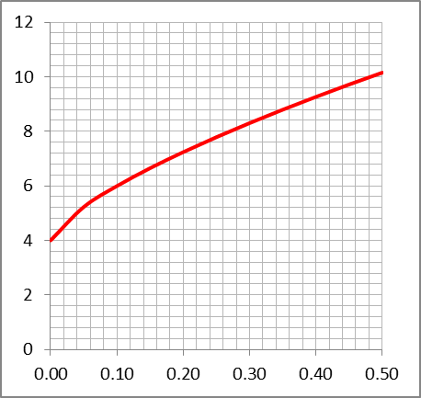

Figure 8

1. What difficulties do you face to determine the following?
2. Exact acceleration at any point in time
3. Exact displacement from 0 s to 0.5 s
4. Suggest how you would estimate the following.
5. Acceleration at a given point
6. Displacement from 0 s to 0.5 s
7. What method can you use to improve the estimates?